DBT_pdf

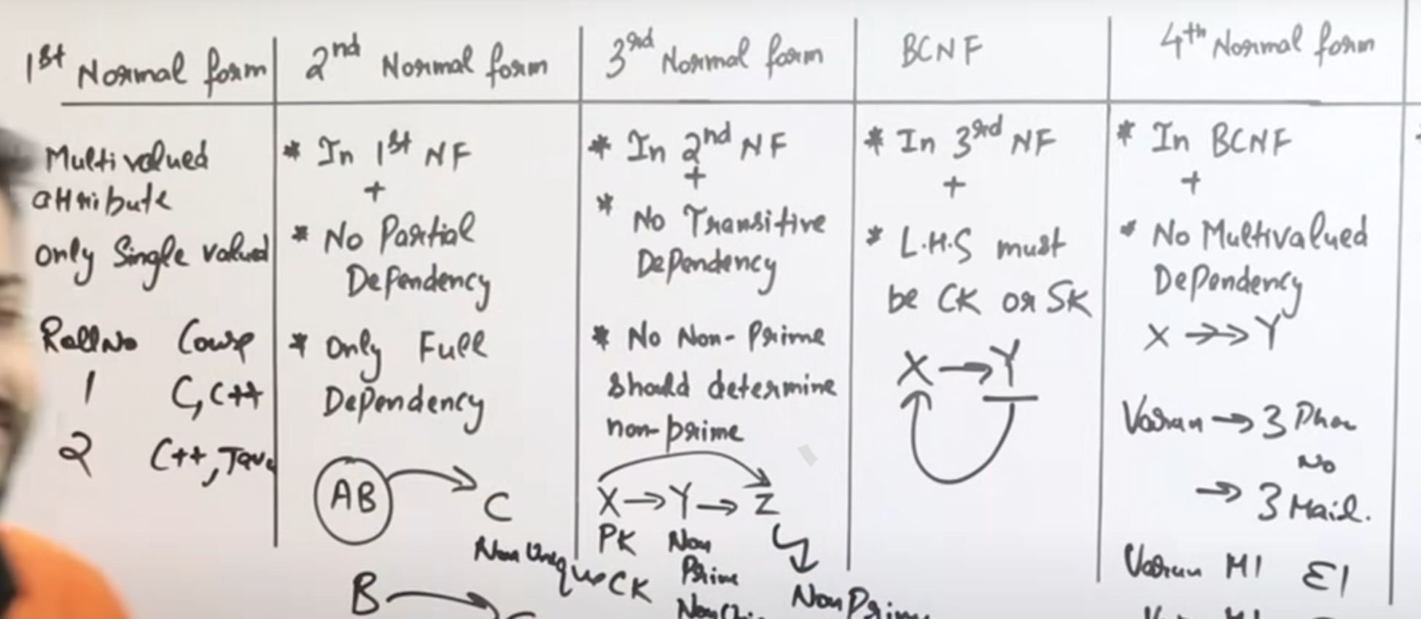

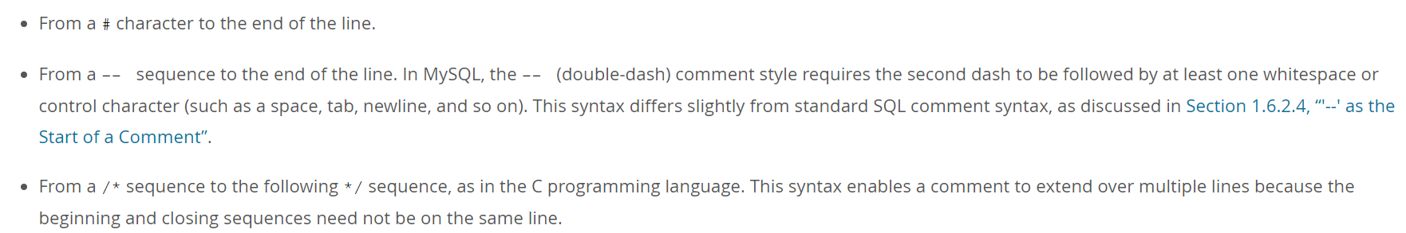 

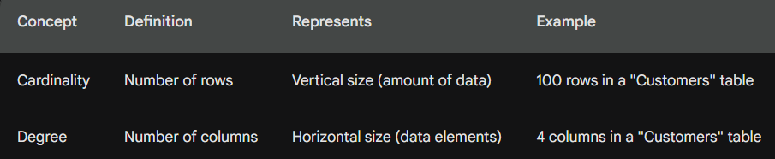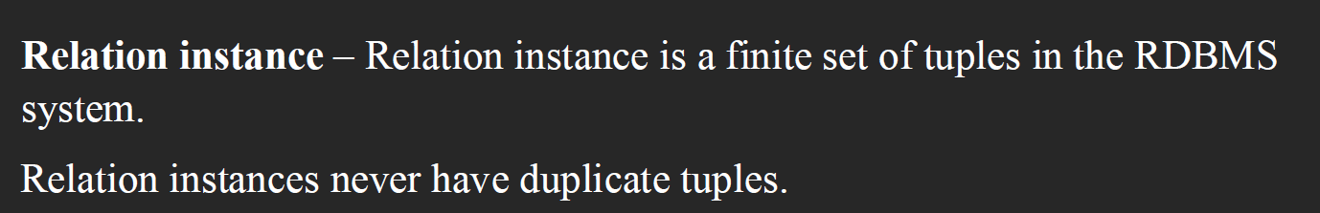

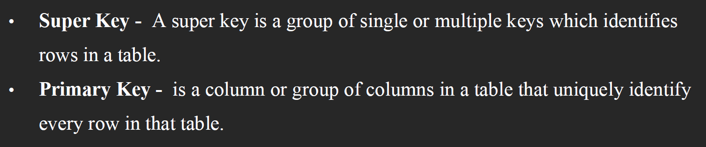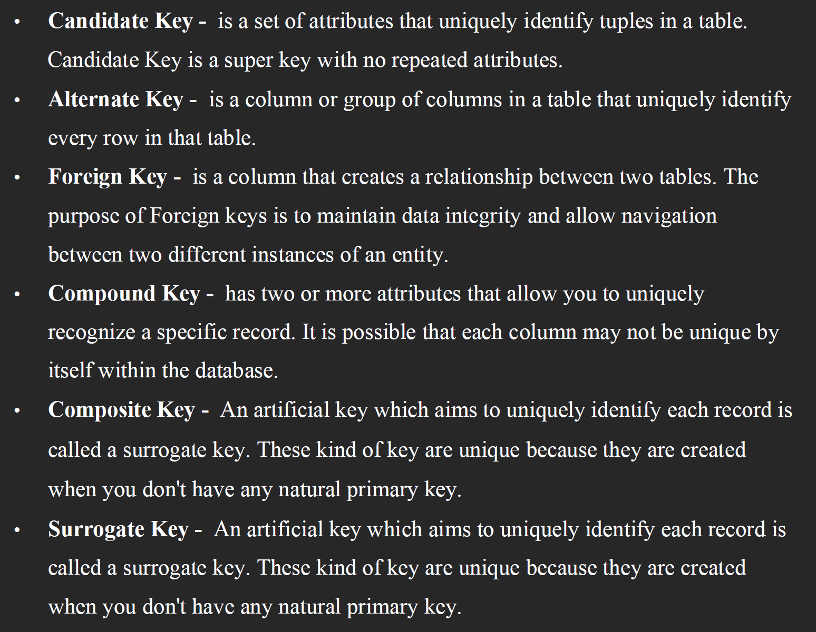

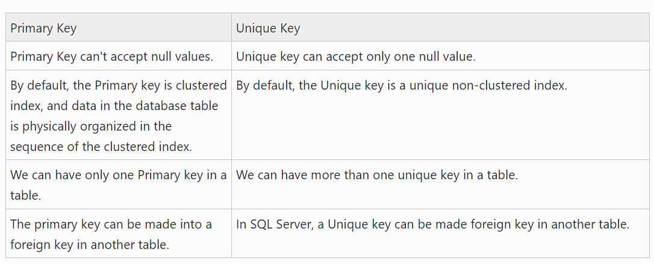

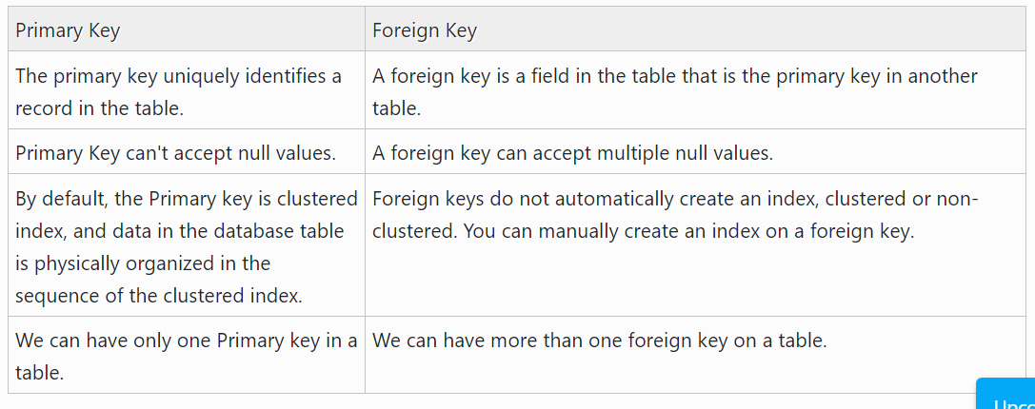

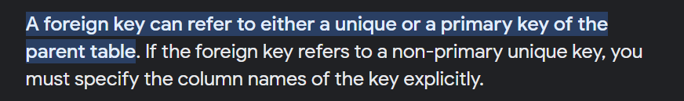

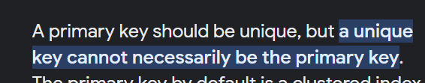



In LIKE

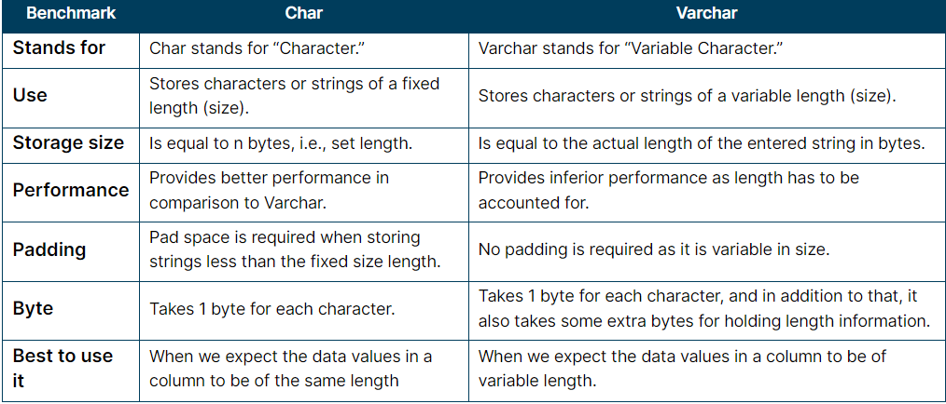

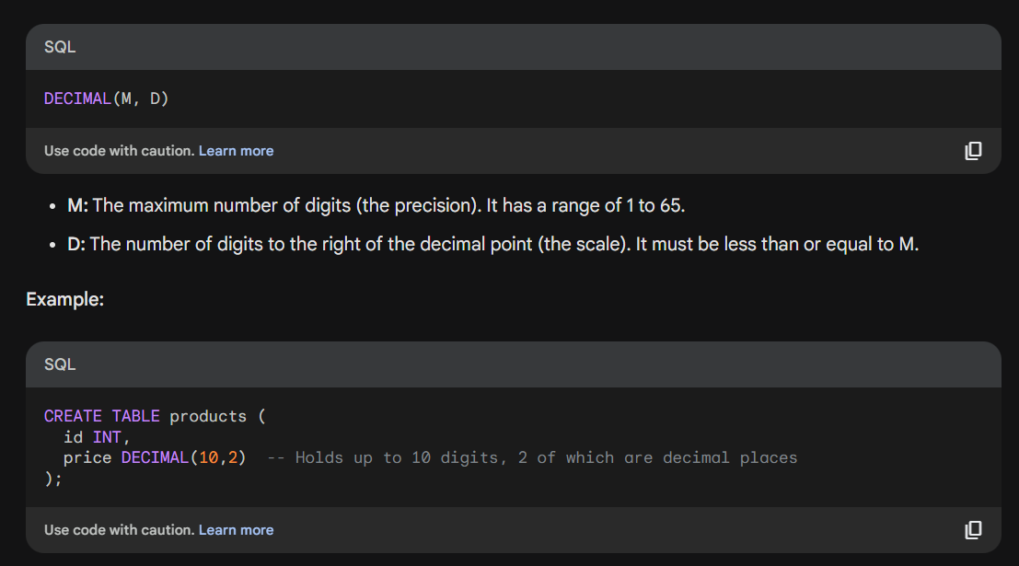

 

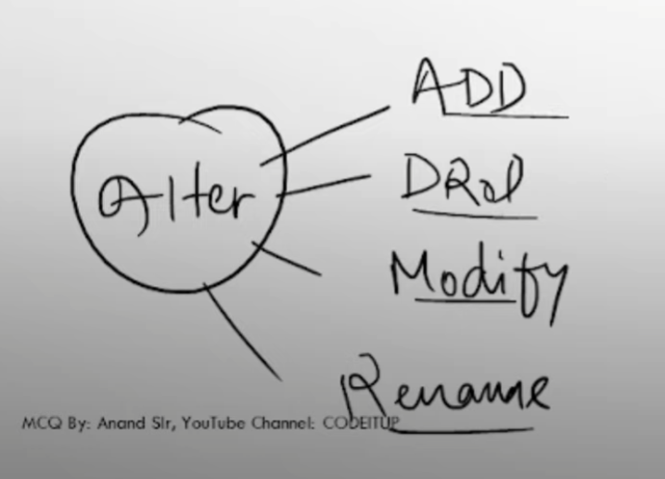

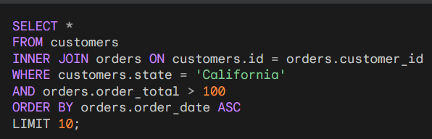

Group by ----- having----- (having should be on column which you have selected group)

  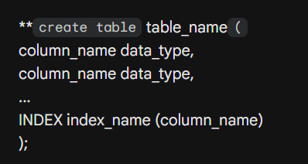

 

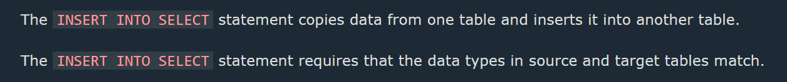

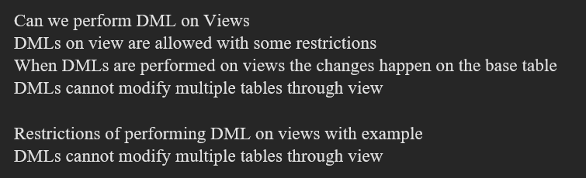

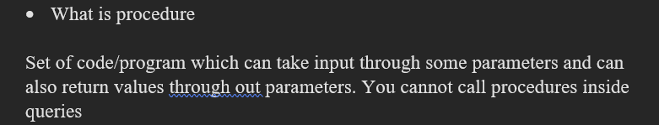

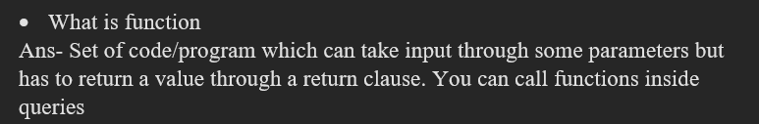

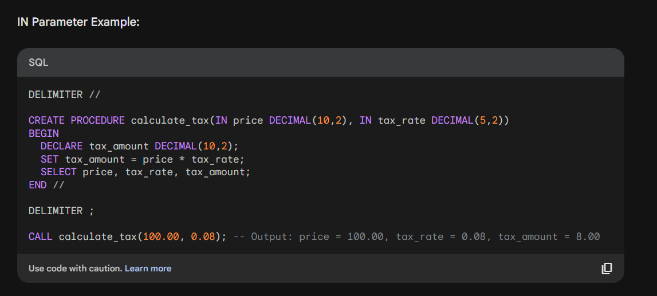

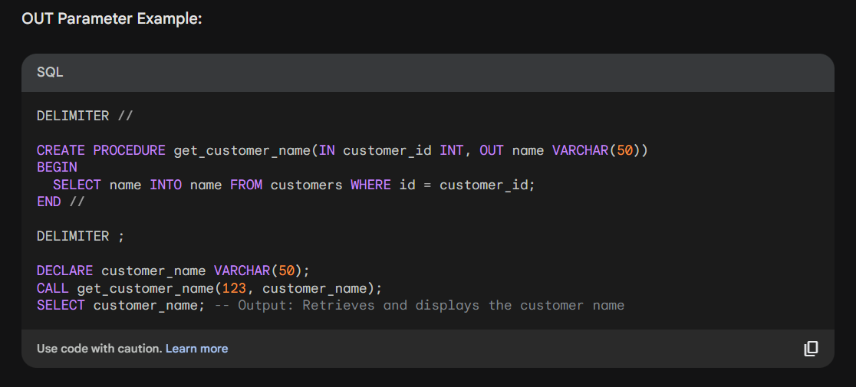

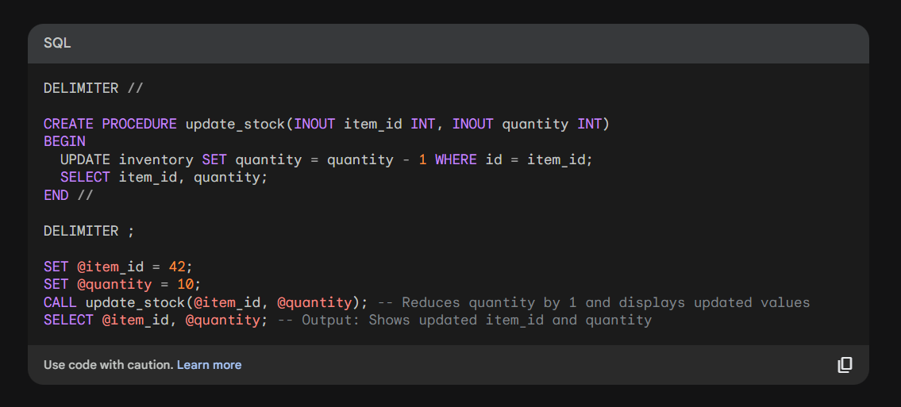

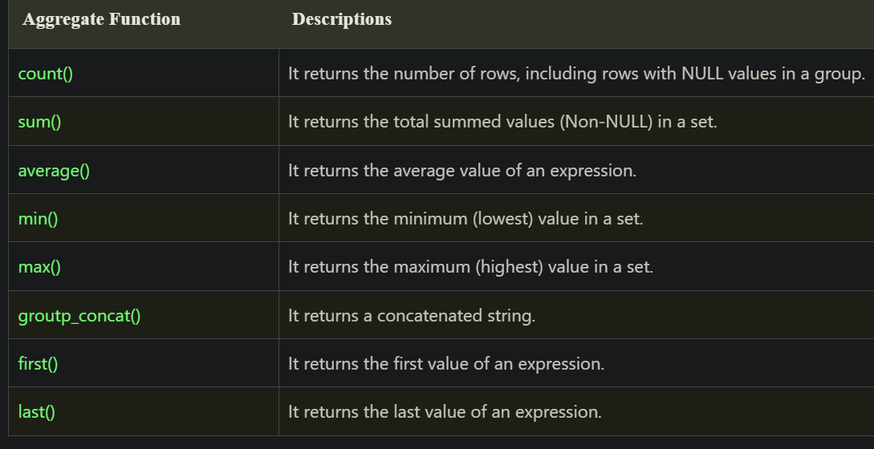



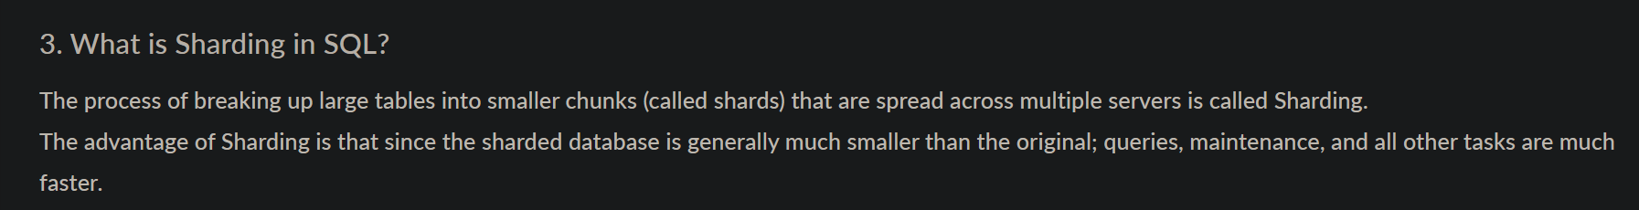

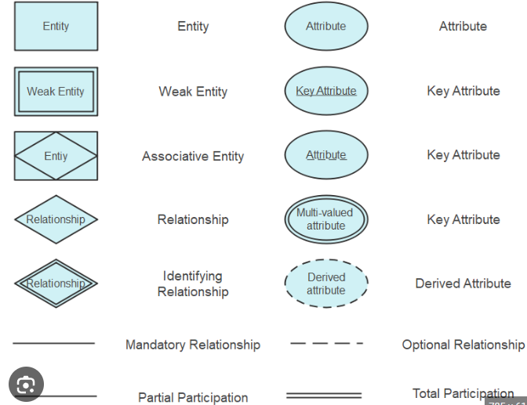

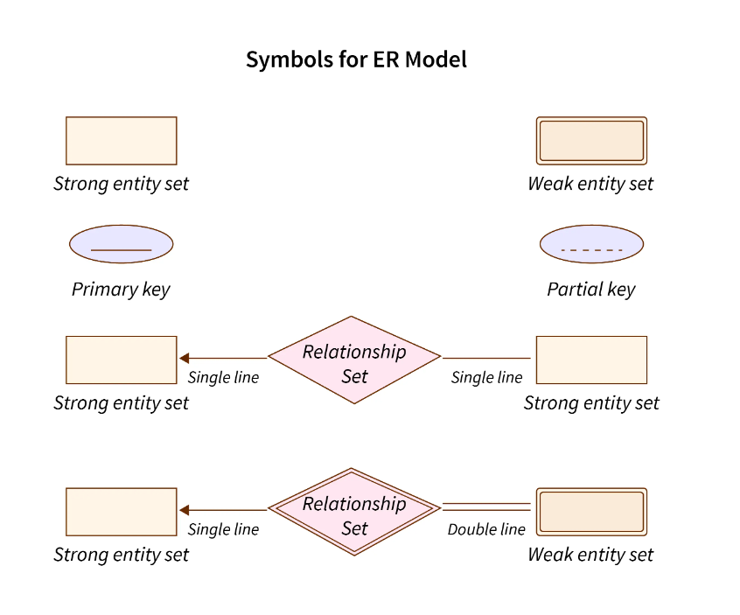

|  |  |  |
| --- | --- | --- |
| Table | Relation, File, Entity, (Rectangle) |  |
| Column | Attribute, Field, Domain, (Oval) | No. of columns 🡪 Degree |
| Row | Tuple, Record | No. of rows 🡪 Cardinality |
| Domain constraints | Data type of domain |  |
| Pool of values | Domain |  |
| Referential integrity | Foreign key |  |
| Entity integrity constraint | Primary key |  |
| Total view | Conceptual view |  |
| Specialization | IS A , Triangle |  |
| Between | From range of values | Between includes both mentioned in condition |
| IN | From given set of values |  |
| Default join | Inner join |  |
| Cartesian product | Cross join |  |
|  |  |  |
|  |  |  |
|  |  |  |
|  |  |  |

Select project

|  |  |  |
| --- | --- | --- |
| Projection | Vertical style fetching, column fetching | Without condition |
| Selection | horizontal style fetching, row fetching | Condition (where) comes under selection |

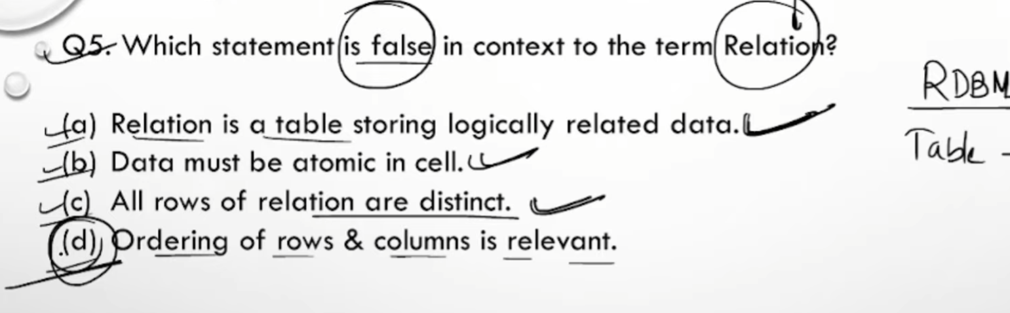



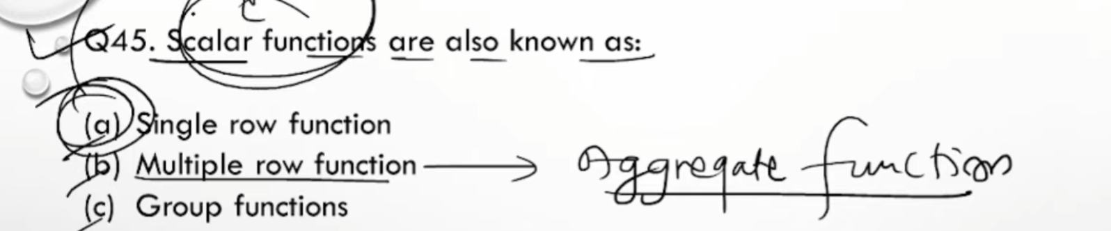

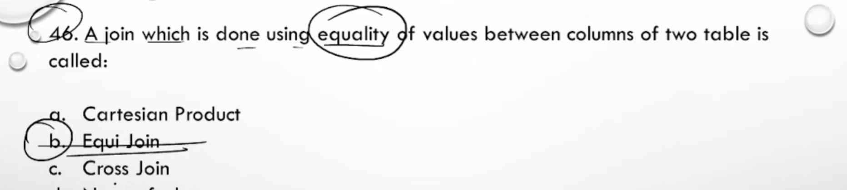

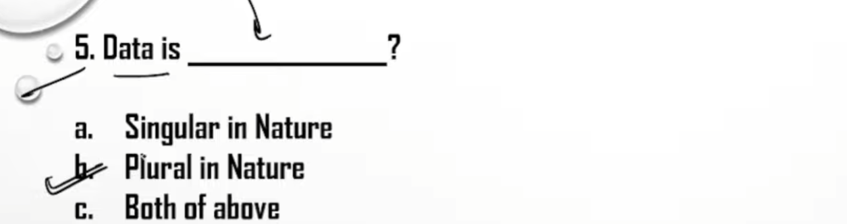

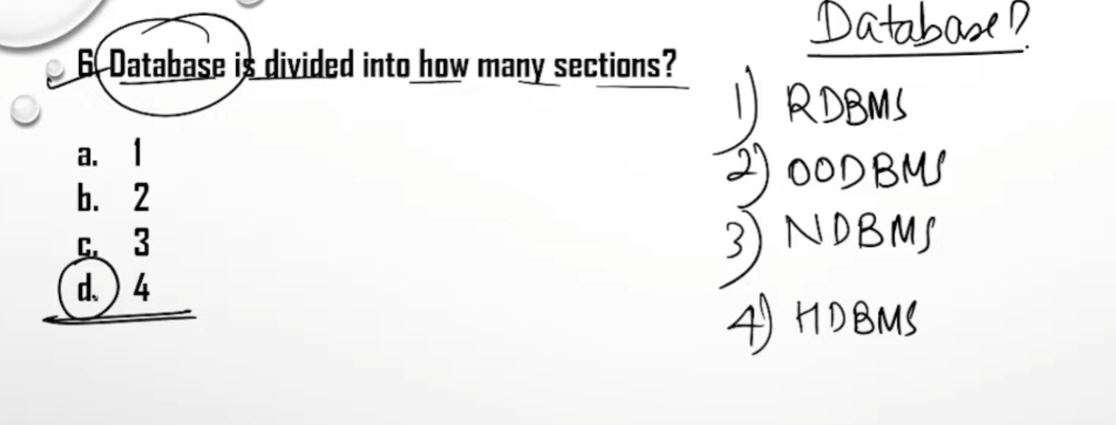

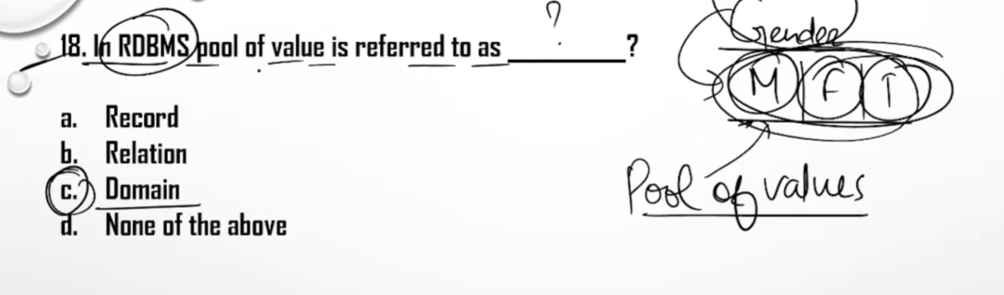

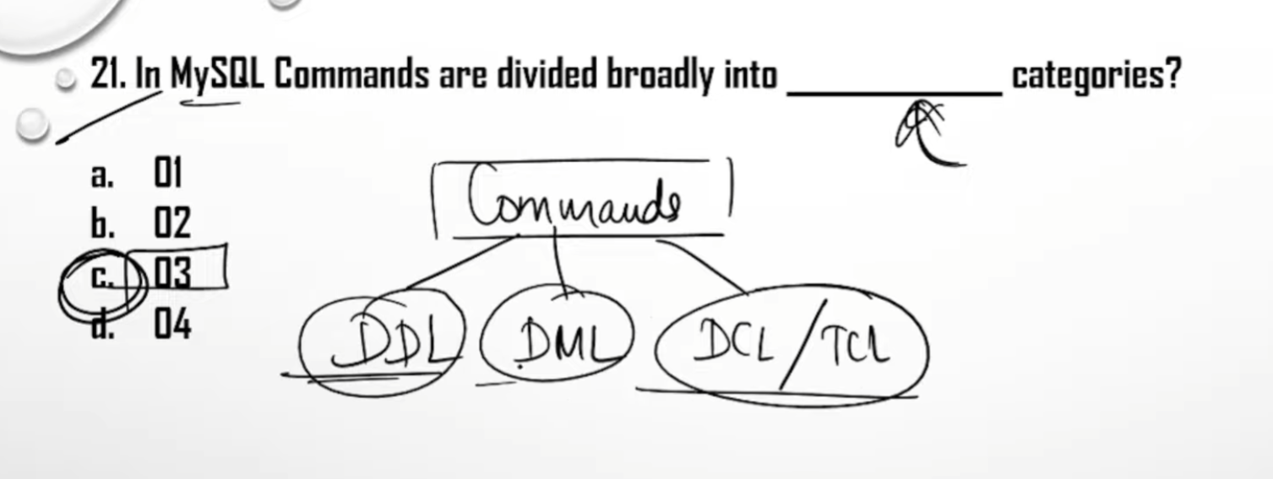

 

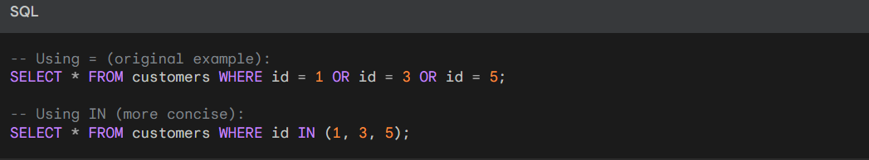

If no join condition is given, it shows cartesion product

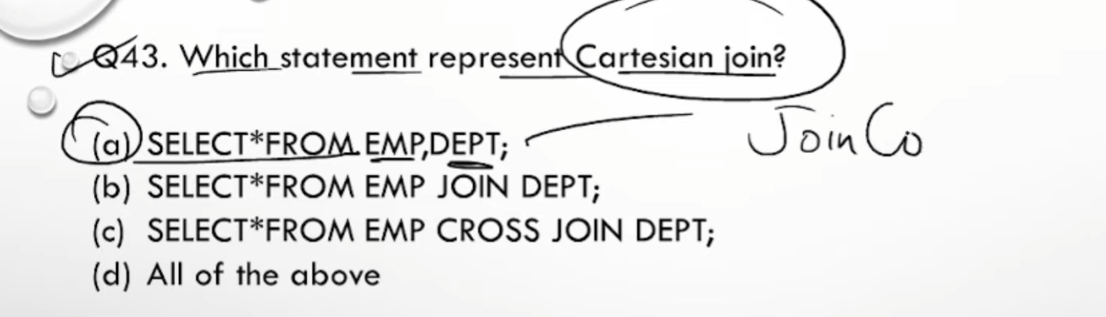

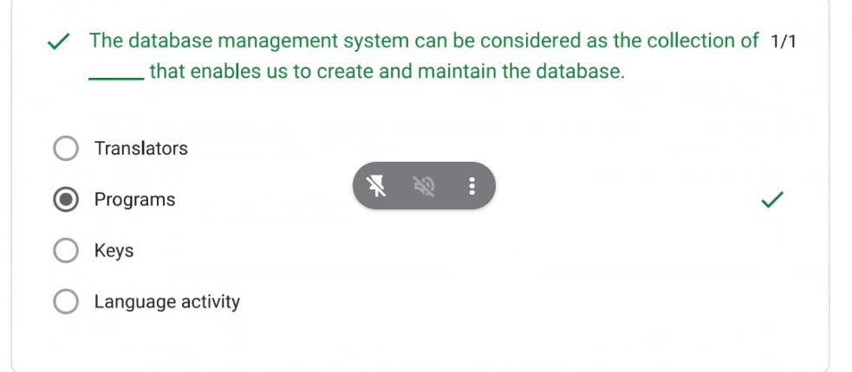

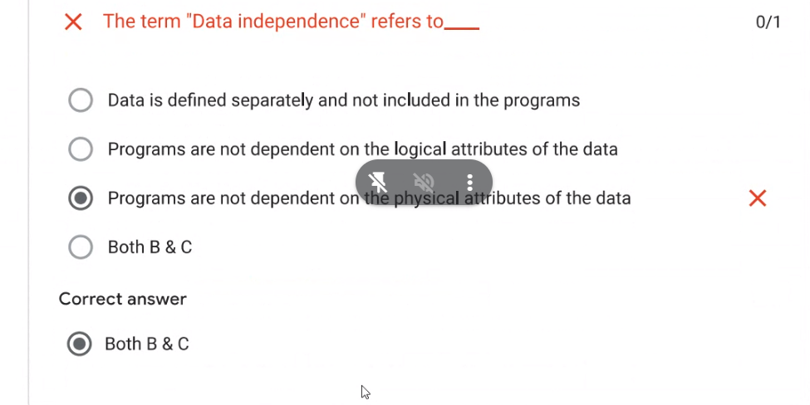

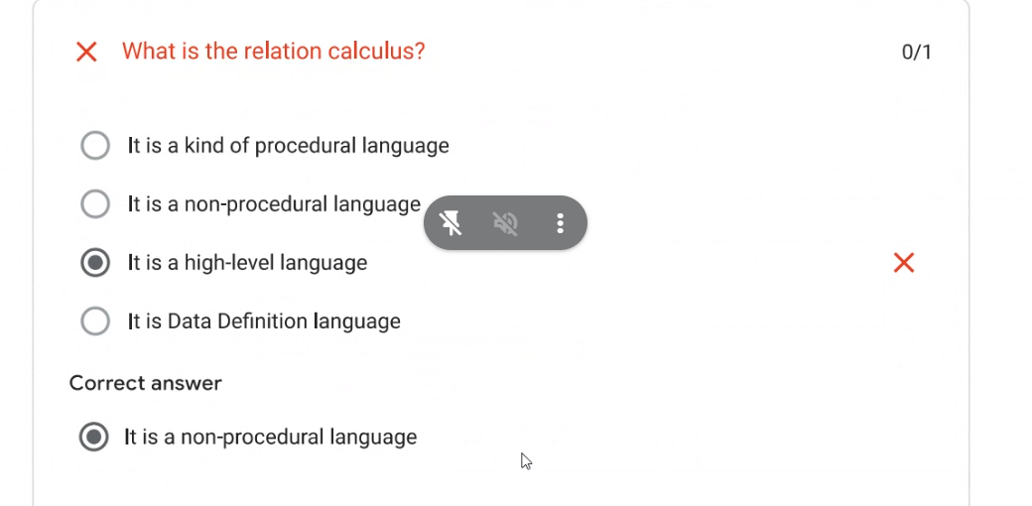

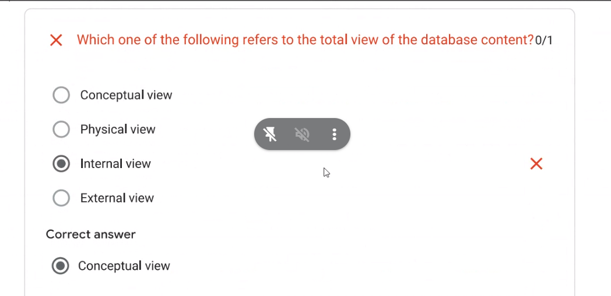

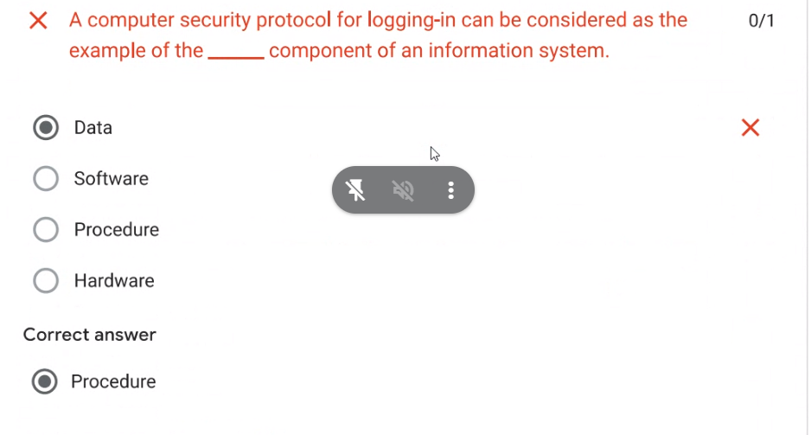

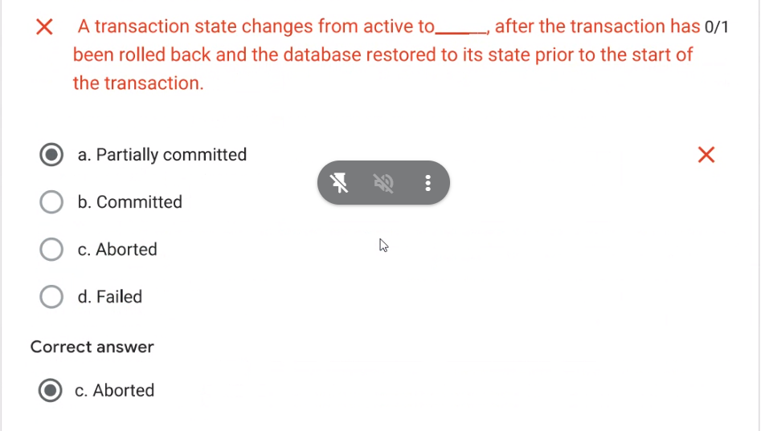

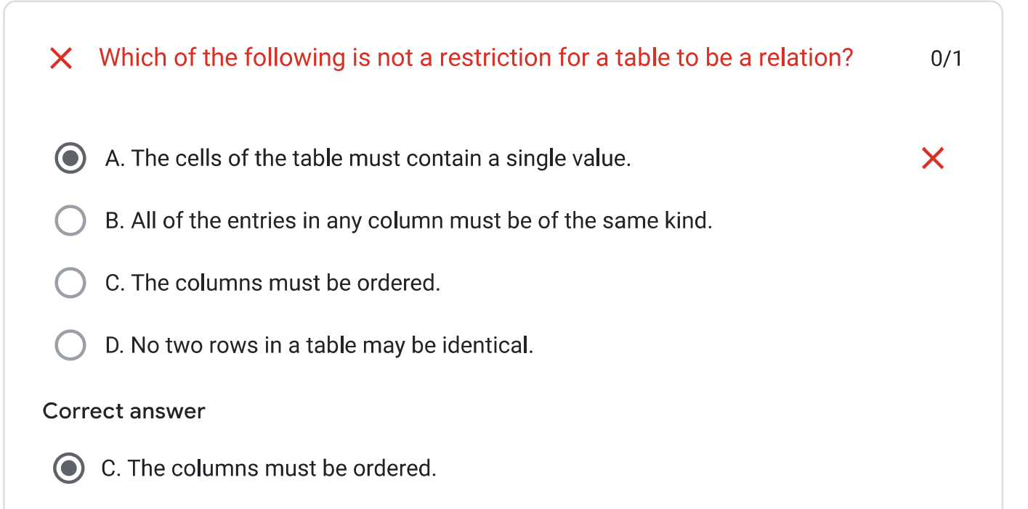

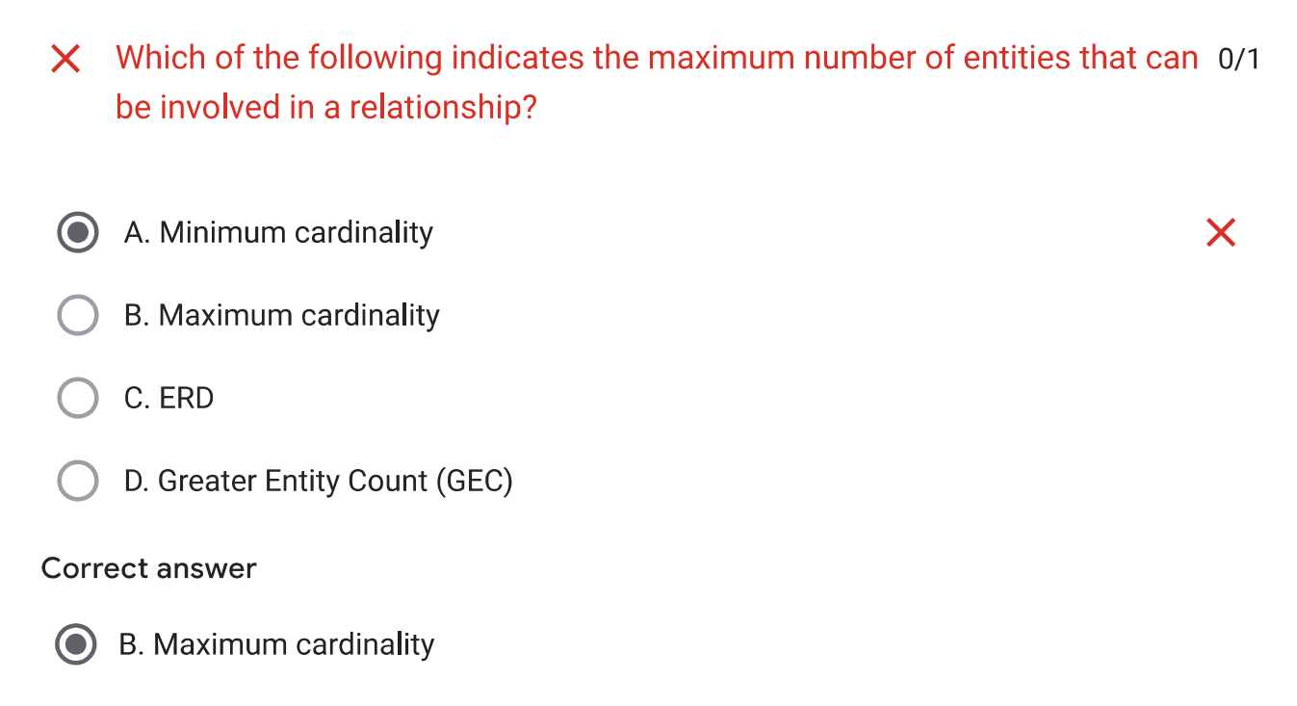

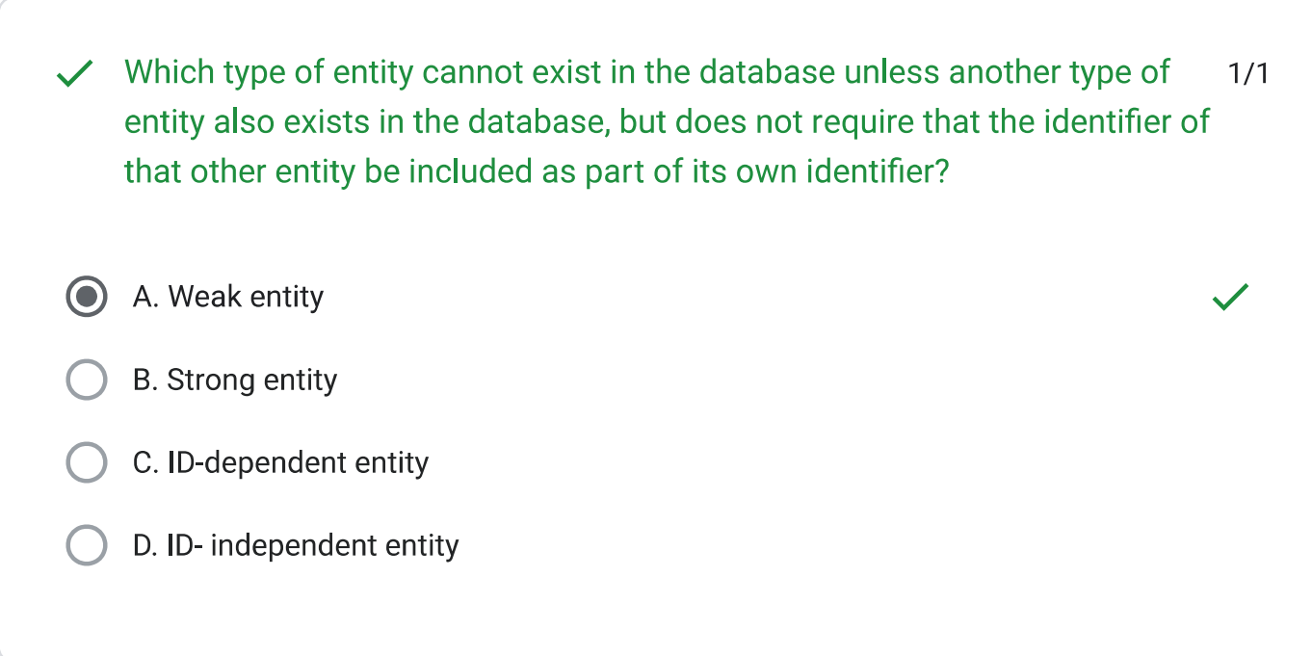

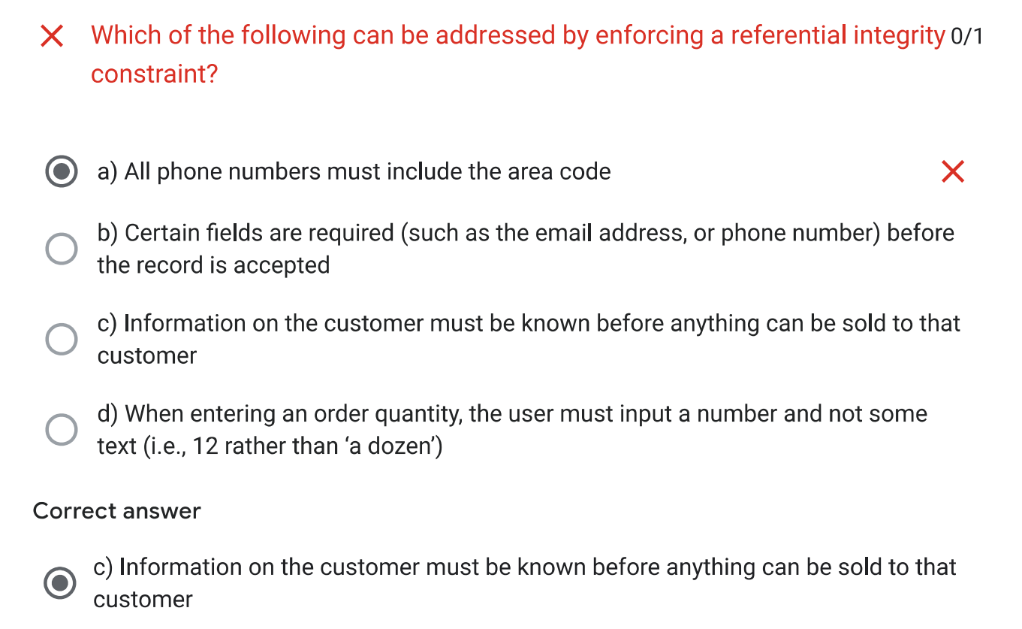

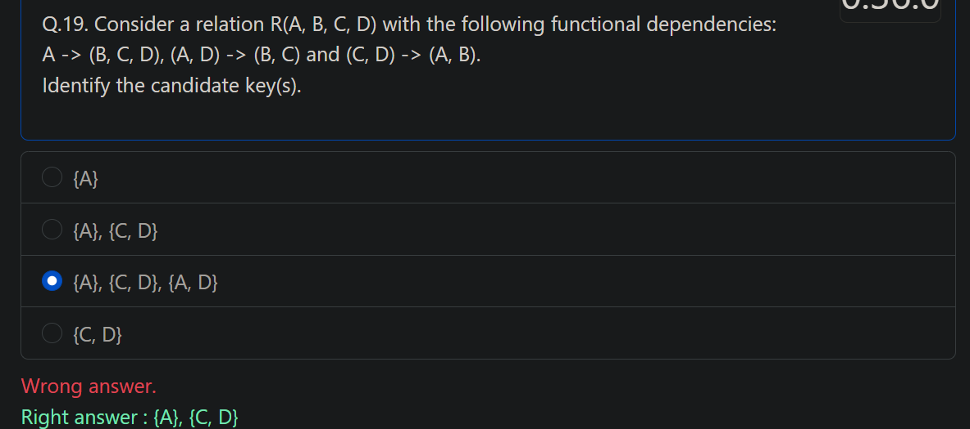

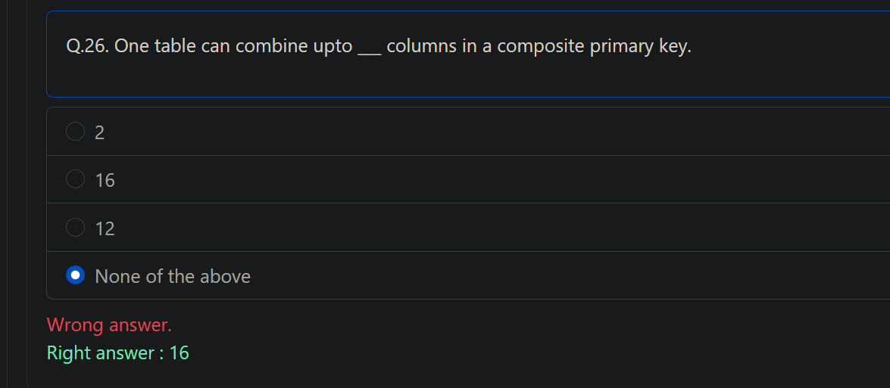

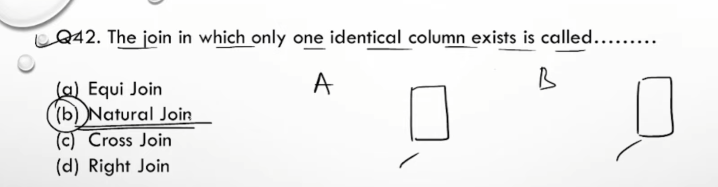

Lecture 12: Introduction to NoSQL Databases and MongoDB

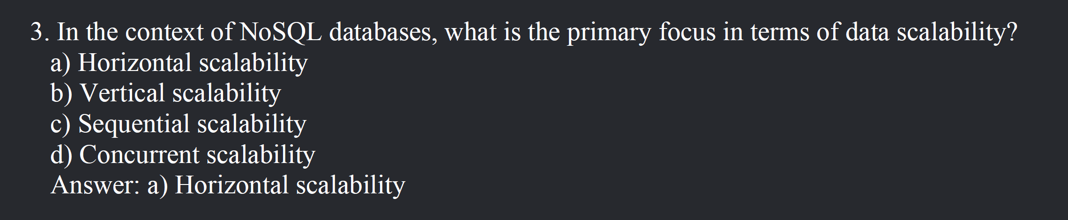

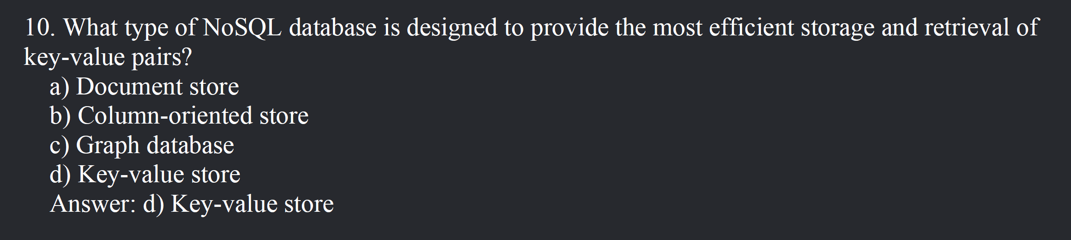

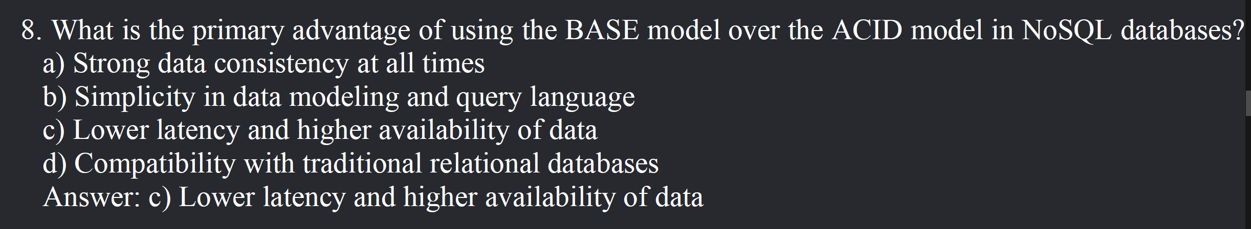

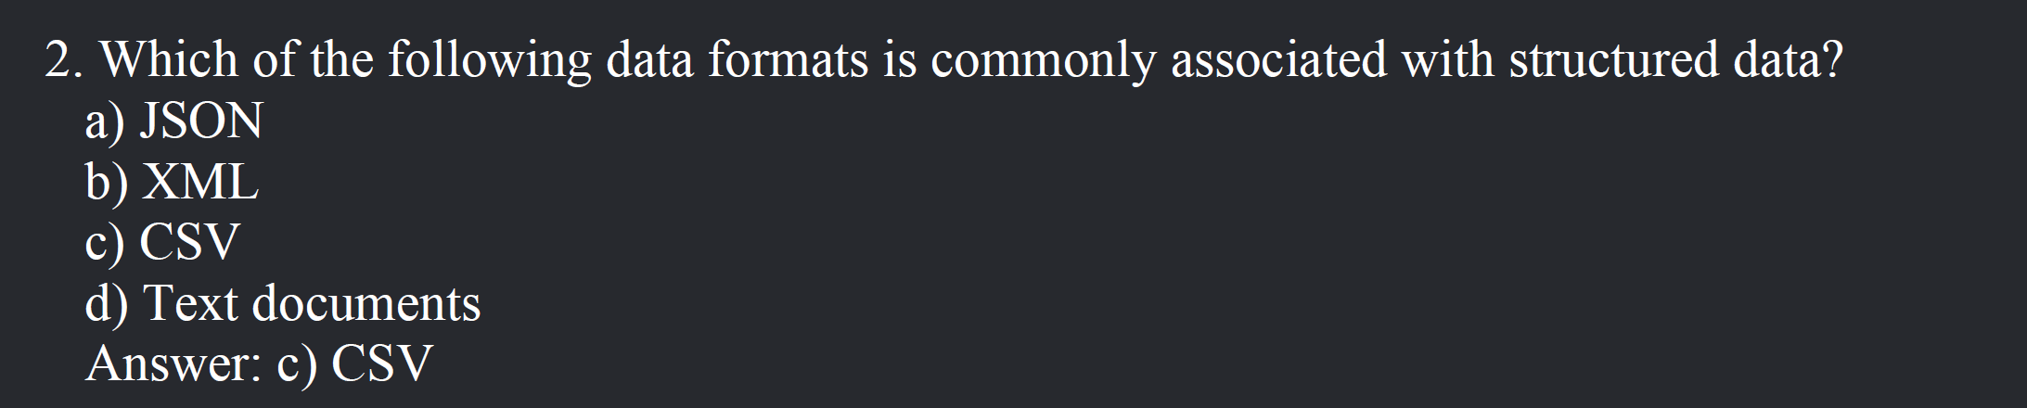

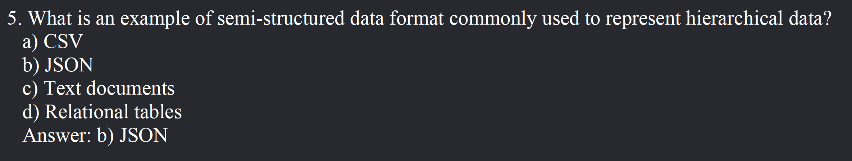

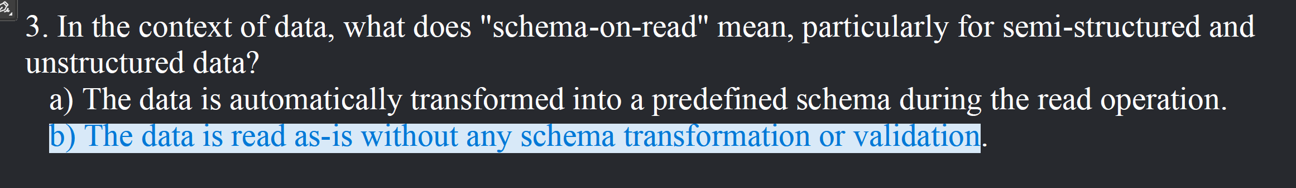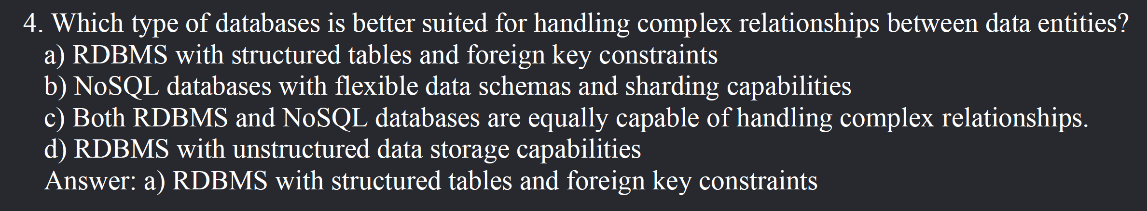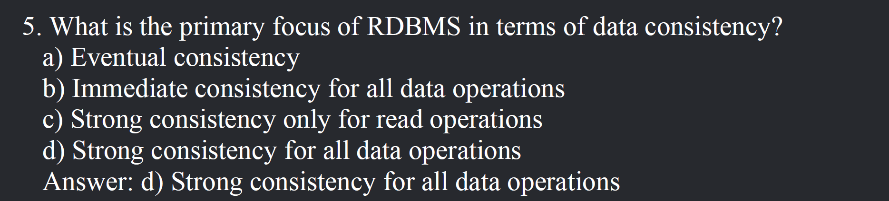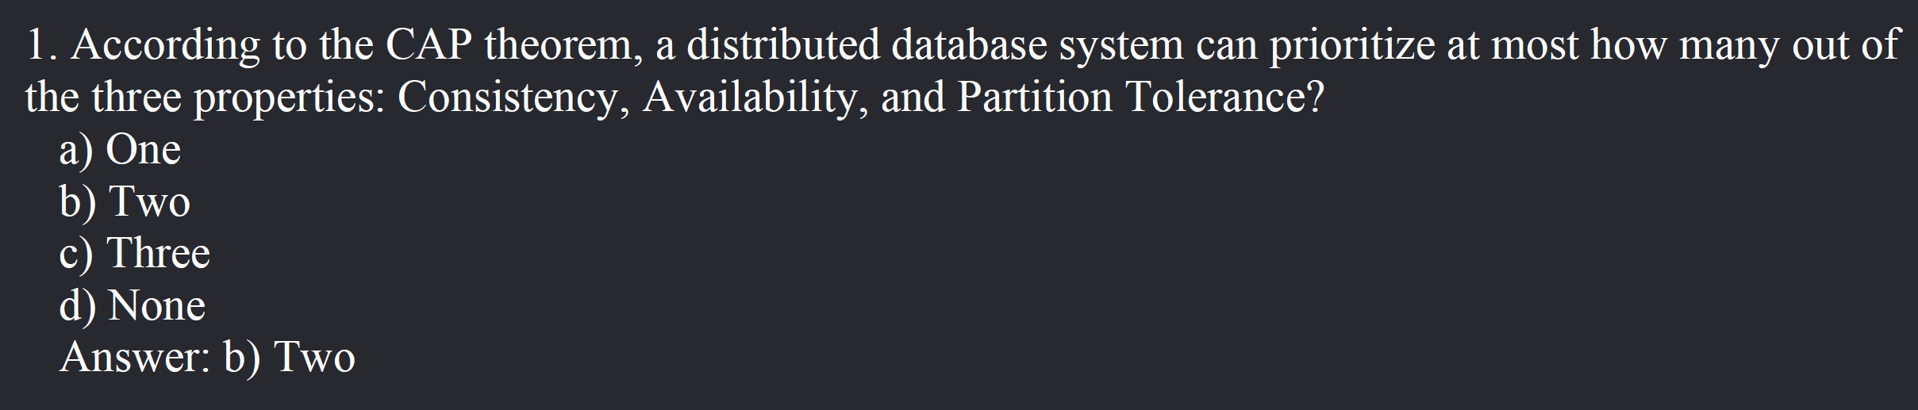

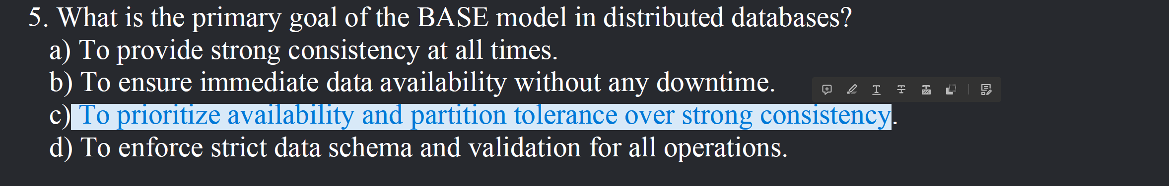

MongoDB



